EXPT NO:2 | LOAD AND VISUALIZE A DATASET USING TABLEAU and PowerBI
DATE: 10.07.2026

PRE-LAB QUESTIONS (PROVIDE BRIEF ANSWERS TO THE FOLLOWING QUESTIONS) 1. 1. Why is Tableau a preferred tool for data visualization?
Tableau is preferred because it provides interactive, easy-to-create, and powerful visualizations for data analysis.

- What is the primary use of a line chart in data analysis?
A line chart is used to show trends and changes in data over time.

- When would you use a tree map instead of a bar chart?
A tree map is used to display hierarchical data and compare the proportion of categories within a limited space.

- What is the significance of filters in Tableau visualizations?
Filters help users focus on specific data, making analysis more interactive and meaningful.

- How does Tableau handle geographic data for visualizations?
Tableau automatically recognizes geographic fields (such as Country, State, or City) and plots them on interactive maps.

IN-LAB EXERCISE:
OBJECTIVE:
To load a dataset into Tableau, create a variety of visualizations, and derive insights from the data using different chart types available in Tableau.
PROCEDURE:
Dataset Selection:
Use the Global Superstore Sales Dataset (available on Kaggle or Tableau's sample datasets).
Ensure the dataset includes fields like Order Date, Category, Region, Sales, Profit, and Customer Segment.
Data Loading:
Open Tableau and connect to the dataset.
Review the dataset structure, field data types, and missing values.
Chart Creations (Step-by-Step):
- Bar Chart:
Objective: Compare total sales by region and category.
Plot Region on the x-axis and Sales on the y-axis.
Add Category as a color dimension.
- Line Chart:
Objective: Visualize sales trends over time.
Place Order Date on the x-axis and Sales on the y-axis.
Set granularity to Month and color by Category.
- Pie Chart:
Objective: Show sales distribution by product category. Assign Category as the dimension and Sales as the measure.
- Scatter Plot:
Objective: Examine the relationship between profit and sales.
Plot Profit on the x-axis and Sales on the y-axis.
Use Sub-Category as the color dimension.
- Heatmap:
Objective: Compare sales across categories and regions.
Use Region and Category as dimensions. Use Sales as the measure and apply color coding.
- Geographical Map:
Objective: Visualize total sales by country.
Set Country as the geographical field. Use Sales to define size and color gradients.
- Tree Map:
Objective: Display sales distribution by category and sub-category.
Use Category and Sub-Category as dimensions, and Sales as the measure.
Customization and Interactivity:
Add filters to explore data subsets interactively (e.g., by year, region, or category).
Include annotations, labels, and formatting for clarity.
Dashboard Creation:
Combine all charts into a single dashboard to present a cohesive story.
Add interactive filters and tooltips for dynamic exploration.
Experiment Dataset:
Global Superstore Sales Dataset
Source: https://www.kaggle.com/datasets/apoorvaappz/global-super-store-dataset
Fields Used:
Order Date
Region
Category
Sub-Category
Sales
Profit
Country

Screenshot:
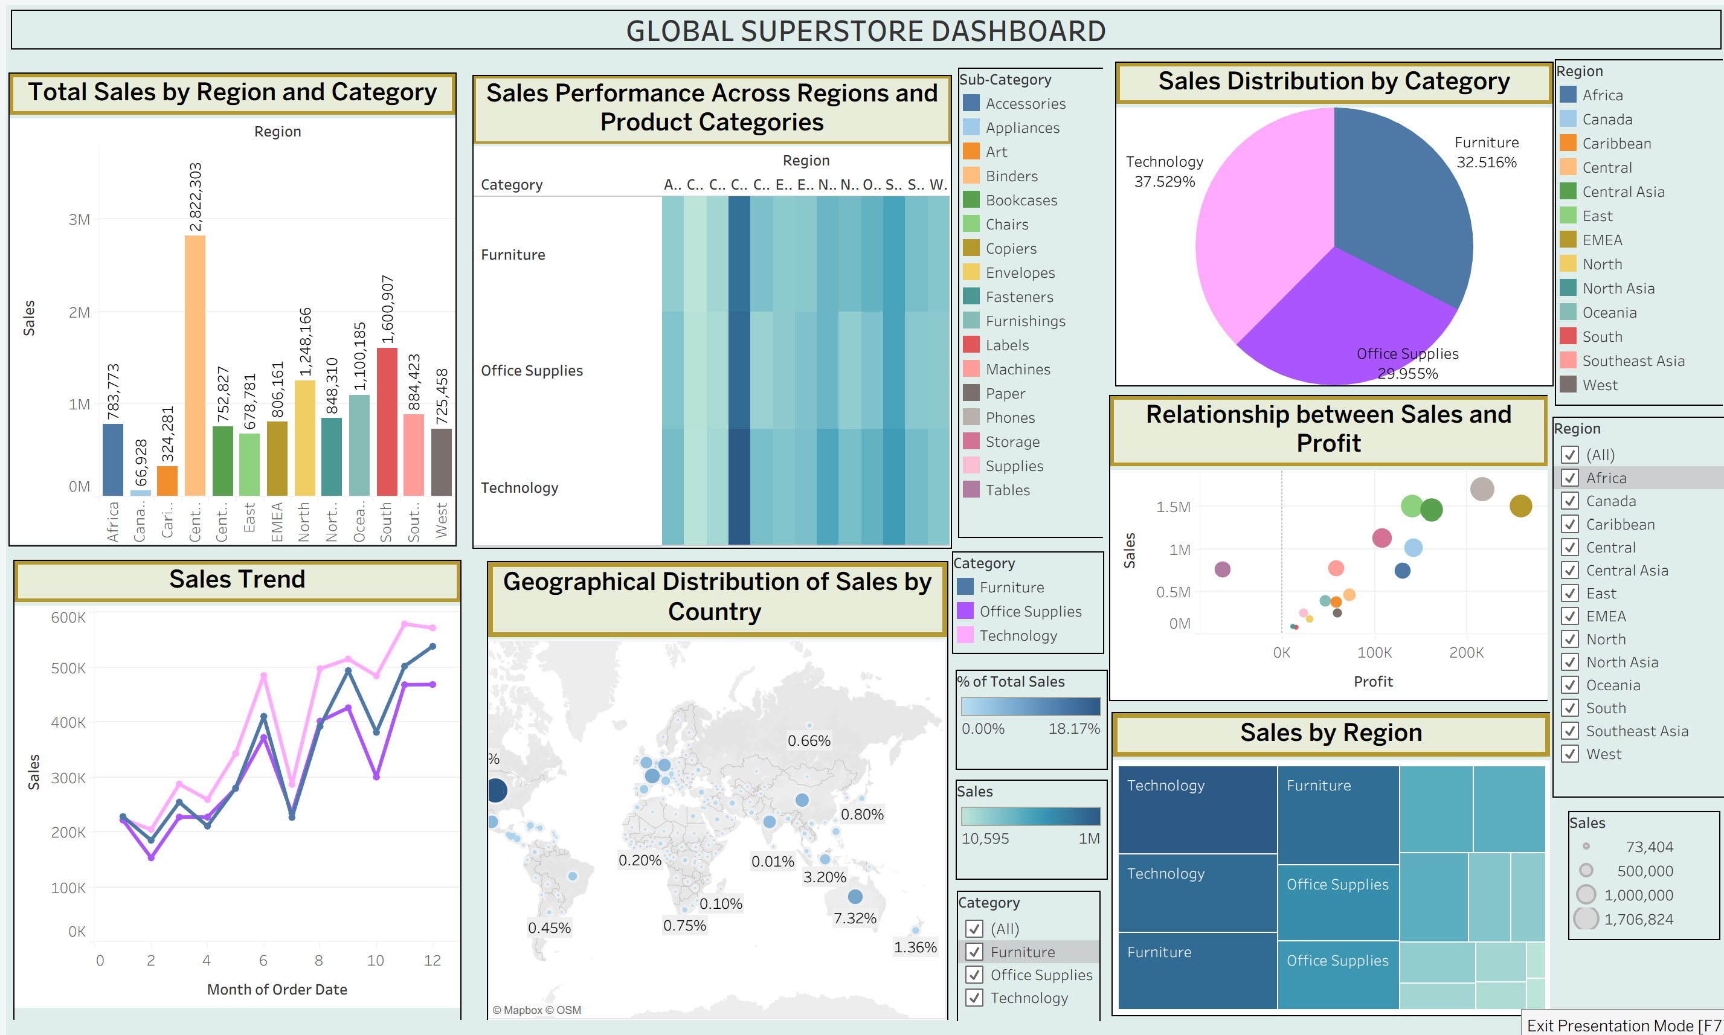

POST-LAB QUESTIONS (PROVIDE BRIEF ANSWERS TO THE FOLLOWING QUESTIONS)
Bar Chart:
What regions had the highest and lowest total sales?
- Highest: West Region
- Lowest: South Region
How does the performance of categories vary across regions?
Technology generally has the highest sales, while Furniture and Office Supplies vary across regions.

Line Chart:
Identify the month with peak sales.
November recorded the highest sales.
Which category shows consistent growth in sales over time?
Technology shows the most consistent growth.

Pie Chart:
Which category contributes the most to overall sales?
Technology contributes the largest share of total sales.
Are there any categories with negligible sales contributions?
No. All categories contribute significantly, though Furniture has the smallest share.

Scatter Plot:
Is there a noticeable correlation between profit and sales?
Yes. Higher sales generally lead to higher profits, but there are some exceptions.
Which sub-category shows the highest sales but low profit?
Tables have relatively high sales but low (or sometimes negative) profit.

Heatmap:
Which region-category combination has the highest sales?
West Region – Technology.
Identify any regions with poor sales performance across all categories.
South Region shows comparatively lower sales.

Geographical Map:
Which country has the highest total sales?
United States.
Are there regions with minimal or no sales?
Yes. Some countries or regions have very low sales compared to others.

Tree Map:
Which sub-category dominates the sales in each category?
- Furniture: Chairs
- Office Supplies: Storage
- Technology: Phones
Are there any sub-categories with unexpectedly low sales?
Yes. Fasteners and Labels have relatively low sales.

Dashboard:
What insights can you derive when combining all visualizations?
The dashboard helps identify sales trends, regional performance, profitable categories, and areas needing improvement in a single interactive view.
How do filters enhance the utility of the dashboard?
Filters allow users to analyze specific years, regions, categories, or countries, making the dashboard more interactive and useful for decision-making.

ASSESSMENT

Description |  | Max Marks | Marks Awarded
Pre Lab Exercise |  | 5
In Lab Exercise |  | 10
Post Lab Exercise |  | 5
Viva |  | 10
 | Total | 30
 |  | Faculty Signature

